OUM

DO.070 User Guide

Al-Gihaz Holding –ERP

Oracle Projects -

How to View/Add a Resource

|  |  |
| --- | --- |
| **Author:** | Muhammad Daniyal Khurshidi |
| **Creation Date:** | 16–Jun-2016 |
| **Last Updated:** | 16–Jun-2016 |
| **Document Ref:** | AG_UG_PM_ VAPR |
| **Version:** | v1.0 |

1. **Title, Service Name, Last Updated Date, Reference Number**, **andVersion** are marked by a Word Bookmark so that they can be easily reproduced in the header and footer of documents. When you change any of these values, be careful not to accidentally delete the bookmark. **You can make bookmarks visible by selecting Tools->Options…View and checking the Bookmarks option in the Show region.**

**Approvals:**

|  |  |  |
| --- | --- | --- |
| **Approver** | **Designation / Role** | **Signature & Date** |
| Hassan Mujahid | Raqmiyat Project Manager |  |
| Dr. Tarek Amer | AG Commercial Director |  |
| Ahmed Al Sokkary | AG Project Manager |  |
|  |  |  |

# Document Control

## Change Record

| Date | Author | Version | Change Reference |
| --- | --- | --- | --- |
| 16–Jun-2016 | Muhammad Daniyal | V1.0 | No Previous document |
|  |  |  |  |
|  |  |  |  |
|  |  |  |  |
|  |  |  |  |
|  |  |  |  |

## Reviewers

| Date | Name | Position | Signature |
| --- | --- | --- | --- |
|  | Muhammad Daniyal | Project Consultant – Raqmiyat |  |
|  | Hassan Mujahid | Raqmiyat Project Manager |  |
|  | Dr. Tarek Amer | AG Commercial Director |  |
|  | Ahmed Al Sokkary | AG Project Manager |  |
|  |  |  |  |
|  |  |  |  |
|  |  |  |  |

## Objective

This document will demonstrate & illustrate how to view/add Resource in resource list.

## Audience

This manual is prepared for Al-Gihaz Projects Business Cycles. The concerned department is Projects.

## How to use this manual

Through the Contents, the user can see how to view or add a planning resource in the resource list in Oracle Projects module.

As per the Future Process Model document; the users will be focused only on certain topics and transactions as per their role.

**Contents**

1 Document Control 2

1.1 Change Record 2

1.2 Reviewers 2

1.3 Objective 3

1.4 Audience 3

1.5 How to use this manual 3

1.6 How to View/Add a Resource 5

## How to View/Add a Resource

1. Log in to Oracle.
2. Go to Project Super User responsibility.
3. Go to Projects: Setup 🡪 Planning Resource List.
4. Click on Update (yellow pencil icon).

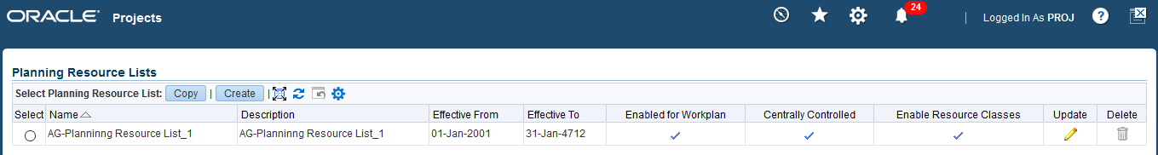

1. Click on the Planning Resources tab.

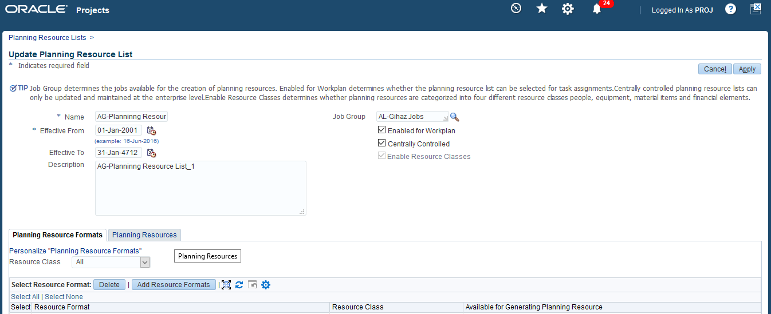

1. To see all the existing resources, just check the resource list in the Planning Tab.
2. If you want to add a resource, for more than one click the “Add Multiple Planning Resources” button or for adding a single resource click “Add Single Planning Resource” button.

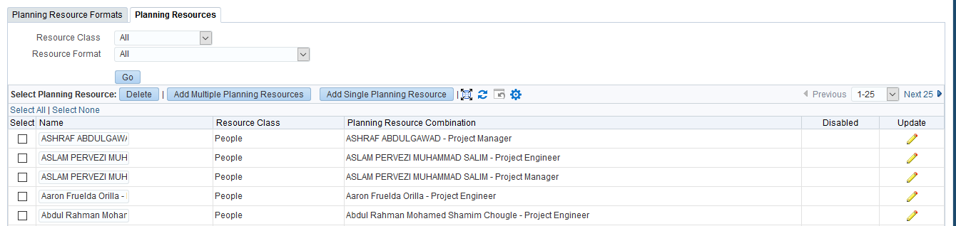

1. Select “People” in Resource Class. In Resource Format select Named Person for an Employee or Team Role for a labor e.g. Mason, Technician, Electrician etc.

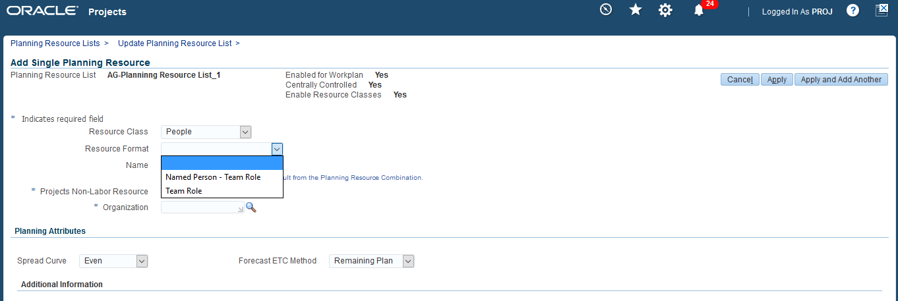

1. For an employee select employee name in the named person field and role from the pre-defined role list.

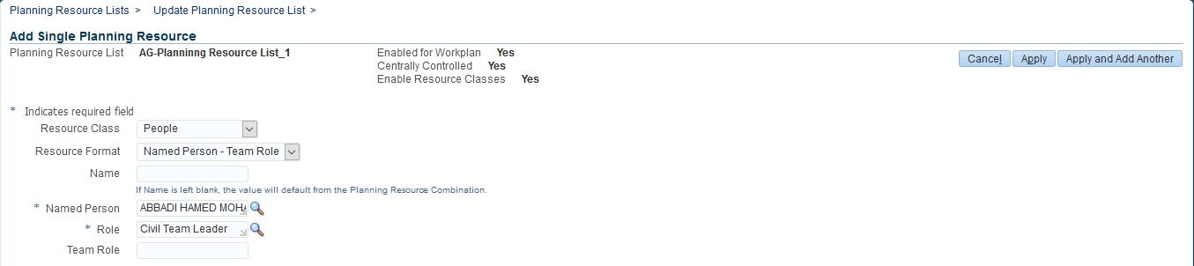

1. For labor select the role from the list.

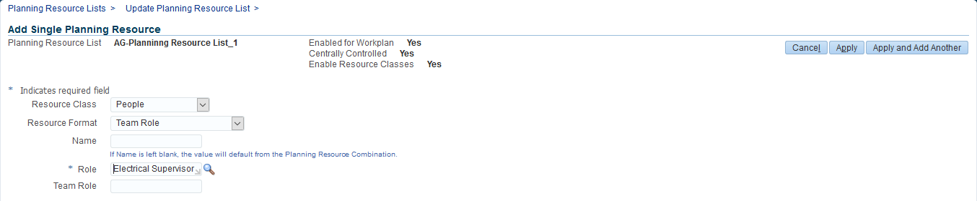

1. Click Apply. The new resource has been added in the list and can be used to assign to a Task in a Workplan in the Projects module.